H.T No
Regulations:
A20

Sreenidhi Institute of Science and Technology
(An Autonomous Institution)
Code No: 8B103 Date: 05-Nov-2021 (FN)

B.Tech I-Year I- Semester External Examination, Oct/Nov-2021 (Supplementary)
ENGINEERING MECHANICS (ME)

Time: 3 Hours Max.Marks:70

Note: a) No additional answer sheets will be provided.
b) All sub-parts of a question must be answered at one place only, otherwise it will not be valued.
c) Missing data can be assumed suitably.

ANSWER ANY 5 OUT OF 8 QUESTIONS. EACH QUESTION CARRIES 14 MARKS.

Bloom's Cognitive Levels of Learning (BCLL)

Remember | L1 | Apply | L3 | Evaluate | L5
Understand | L2 | Analyze | L4 | Create | L6

 |  |  | BCLL | CO(s) | Marks
1. | a) | Analyze the meaning of Free Body Diagram. | L4 | CO1 | [4M]
 | b) | Three bars, pinned together B and C and supported by hinges at A and D as shown in figure below form a four - link mechanism. Evaluate the value of P that will prevent motion.  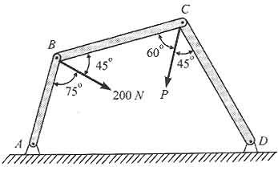 | L5 | CO1 | [10M]
2. | a) | Analyze and explain principle of virtual work. | L4 | CO2 | [4M]
 | b) | The cantilever truss in Fig.02. is hinged at D and E. Distance between D and E is 5M Evaluate the force in each member  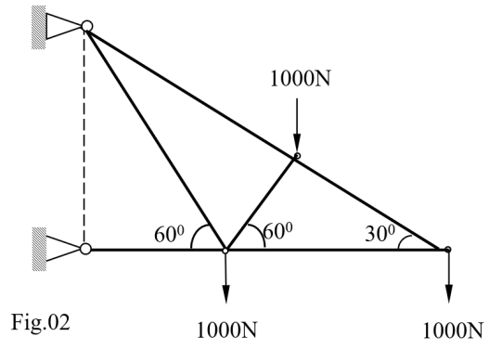 | L5 | CO2 | [10M]
3. | a) | Understand and prove theorems of Pappus and Guildinus. | L2 | CO3 | [7M]
 | b) | Evaluate the force P required to start the wedge as shown in Fig. The angle of friction for all surfaces in contact is 15⁰  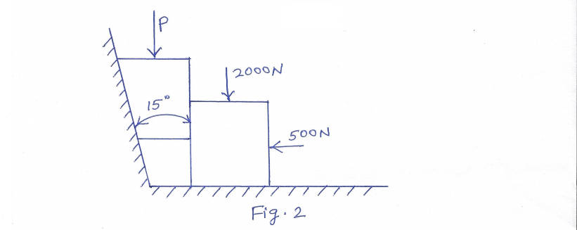 | L5 | CO3 | [7M]
4. |  | From a rectangular cross section, 80 mm wide and 100 mm high, two semi-circular portions of each 60 mm dia. are removed as shown in fig.04. Analyze I_{xx} and I_{yy} for the cross section  y  y  x  x  30  30  40  40  50  50  Fig.04 | L4 | CO4 | [14M]
5. |  | Two bodies of weights 40 N and 15 N are connected to the two ends of a light inextensible string, which passes over a smooth pulley. The weight 40 N is placed on a smooth incline plane while the weight 15 N is having free in air as shown in Fig below. If then angle of the inclined plane is 15º Evaluate i) acceleration of the system ii) tension in the string  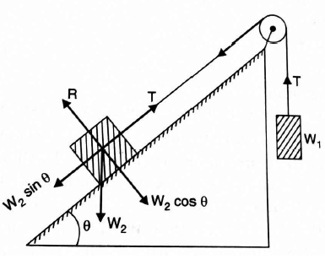 | L5 | CO5 | [14M]
6. |  | A block and pulley system is shown in the figure below. The coefficient of kinetic friction between plane and block is 0.3. if the pulley is frictionless, Analyze the acceleration of the blocks and the tension in the string when the system is just released. Also find the time required for 200 Kg block to come down by 2m.  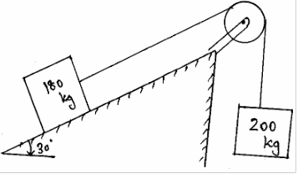 | L4 | CO6 | [14M]
7. | a) | Create the necessary and sufficient condition for a static equilibrium of a particle in two dimensions. | L6 | CO1 | [5M]
 | b) | Understand the terms and explain statically determinate truss and statistically indeterminate truss? | L2 | CO2 | [5M]
 | c) | Understand the terms and discuss angle of friction, angle of repose and cone of friction. | L2 | CO3 | [4M]
8. | a) | Evaluate the moment of inertia of a rectangle about its centriod is same as the M.I. of a triangle about its base. | L5 | CO4 | [5M]
 | b) | A stone is dropped from a height. After falling 5 seconds from rest, the stone breaks the glass pane and in breaking the stone losses 20 % of its velocity. Analyze the distance travelled by the stone in the next second. | L4 | CO5 | [5M]
 | c) | Remember and discuss about the law of conservation of momentum. | L1 | CO6 | [4M]
-- 00 -- 00 –

